City of Casey |  | Waste unit | Grade 3- 6
Victorian Curriculum Links
Science  Science knowledge helps people to understand the effects of their actions (VCSSU056)  A change of state between solid and liquid can be caused by adding or removing heat (VCSSU059)  Natural and processed materials have a range of physical properties; these properties can influence their use (VCSSU060)  With guidance, identify questions in familiar contexts that can be investigated scientifically and predict what might happen based on prior knowledge (VCSIS065)  Represent and communicate observations, ideas and findings to show patterns and relationships using formal and informal scientific language (VCSIS072)  Changes to materials can be reversible, including melting, freezing, evaporating, or irreversible, including burning and rusting (VCSSU077)  Scientific understandings, discoveries and inventions are used to inform personal and community decisions and to solve problems that directly affect people’s lives (VCSSU073)  Use a range of methods including tables and column graphs to represent data and to identify patterns and trends (VCSIS069) |  | Literacy  Listen to and contribute to conversations and discussions to share information and ideas and negotiate in collaborative situations and use interaction skills, including active listening and clear, coherent communications (VCELY275)  Plan and deliver short presentations, providing some key details in logical sequence, using appropriate tone, pace, pitch and volume (VCELY276)  Plan, rehearse and deliver presentations incorporating learned content and taking into account the particular audiences and purposes such as informative, persuasive and imaginative, including multimodal elements (VCELY308)  Interpret ideas and information in spoken texts and listen for key points in order to carry out tasks and use information to share and extend ideas and use interaction skills (VCELY307)  Clarify understanding of content as it unfolds in formal and informal situations, connecting ideas to students’ own experiences, and present and justify a point of view or recount an experience using interaction skills (VCELY337) | Personal and social capability  Demonstrate skills for effective participation in group tasks and use criteria provided to reflect on the effectiveness of the teams in which they participate (VCPSCSO023)  Identify the characteristics of an effective team and develop descriptions for particular roles including leadership, and describe both their own and their team’s performance when undertaking various roles (VCPSCSO032)  Describe the various causes of conflict and evaluate possible strategies to address conflict (VCPSCSO033)
Teacher notes:
This curriculum resource has been designed to support students in the City of Casey to understand about the sources of waste separation and different solutions for waste problems. The lessons can be taught isolated or within the context of a unit of work.
Future learning opportunities: | - Follow up this learning task by contacting the Waste Education Team for a ‘Recycle Right’ incursion, Q&A session, staff, or parent workshop.

- IWB/ Whiteboard  - Coloured/ grey led pencils | - To learn about landfill processes.  - Explore items that can go into landfill.  - Discuss the importance of reducing waste. | - Discuss what happens to the rubbish we can’t recycle?  - Recycling is good but not everything can be recycled. | - Research images of landfill and discuss that items that cannot be recycled, or contaminated items that should have been recycled, are buried in landfill sites across the state.  - Ask students what the issues may be with this process? | - Students work individually, or in small groups, to research landfill facts in Victoria.  - Discuss the issues with landfill and possible solutions (discuss Teracycle, Donating items, Container Deposit Scheme) Think about the 5 R’s – Refuse single use plastic in the first place, reduce what you buy, reuse what you already have, repurpose once the item is finished with and finally recycle.  Task options:  - Students write an information report about landfill – the items that go to landfill, the process of burying waste and the dangers involved.  - Students prepare a poster displaying the different levels of landfill. Display a landfill annotation on the IWB/ TV while students are preparing their poster to assist with the correct information.  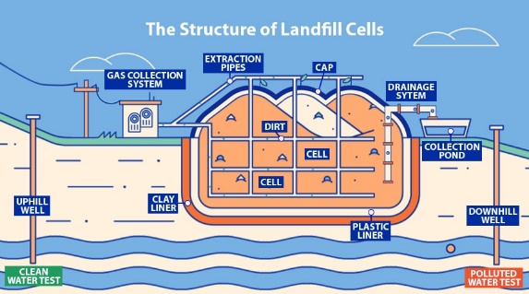  Source: https://ecoresources.net.au/what-is-landfill/  Eco Resources: What is a landfill? | Reflection:  - Share the key information from their research.  - Ask students what they know about landfill now and what actions can be taken to reduce waste.  Assessment:  - Monitor students for understanding of landfill processes.  - Review and annotate completed work.  - Provide feedback to clarify any misconceptions
- IWB or TV  - iPads or Laptops | - To learn about the R’s of waste management.  - Explore each element of the R’s.  - Discuss the importance of reducing waste. | - What does Reduce, Reuse, Recycle mean?  - Are there additional R’s? | - Discuss ‘Rethink’ as the first R of waste management – why do you think this is the first?  - Numberock – Reduce, Reuse, Recycle Earth Song  https://tinyurl.com/3evd77f7 | - Students work individually or in small groups to create a promotion for the R’s of waste management.  - Research each element of the R’s and what each step means.  - Encourage students to think outside the box:  - Song parody about the R’s  - Poem  - Rap  - Poster  - Comic Strip  - News report  Example song parody: (Tune of Shotgun) “Plastic bags I’ll see you later, see you later. Got my canvas bags, my canvas bags.  There’s climate change in the atmosphere, polluted air too familiar. Don’t wanna get used to this. Time flies by when you’re chopping down trees. Take a look and you’ll see what I mean. There are three simple ways we can make change and it goes a little something like this.  Reduce all your plastic waste. Reuse what you’ve already got. Recycle all the extra things. Reduce all your plastic waste. Reuse what you’ve already got. Recycle all the extra things.” | Reflection:  - Share the key information from their research.  Assessment:  - Monitor students for understanding of waste management stages.  Allow students multiple sessions if required to complete their projects.
- IWB or TV  - iPads of laptops | - To learn about the impact of food waste.  - To explore how much food is wasted in Australia. | - Ask students to describe ‘waste’.  - Write ideas for ‘waste’ on post it notes or form a Word Cloud to return to at the end of the unit.  https://wordart.com/ | - Discuss that not all waste is recyclable, in fact not all waste is made of plastic, glass or metal. Food waste is a huge problem in Australia.  - Discuss Food Bank statistics and how to find information on food waste in Australia.  https://www.foodbank.org.au/food-waste-facts-in-australia/?state=vic  - Model how to research accurate and appropriate facts. | - Students collect and collate data and facts on food waste in Australia and what this equivalent is in terms of C02, money and weight.  - Students can incorporate ICT skills using Canva, PowerPoint or Microsoft Word to publish their collated data.  Example:  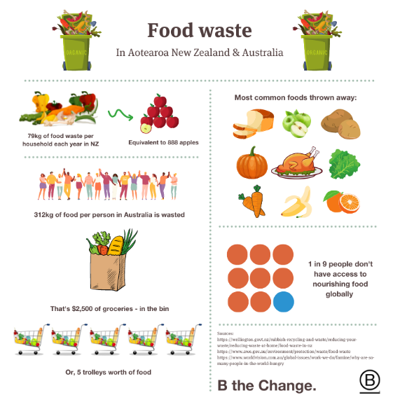  Source: https://bcorporation.com.au/blog/composting-and-the-climate-crisis/ | Reflection:  - Share the key information from their research.  Assessment:  - Monitor students for understanding of food waste and the impacts.  - Check in with learning intention to identify student understanding.  Allow students multiple sessions if required to complete their data collection and displays.
- Recycled materials (boxes, plastic, string, cds)  - Masking tape  Reverse Art Truck is a wonderful source of recycled materials – consider an excursion there with the students.  Located in Narre Warren North.  https://rat.org.au/ | - To explore the benefits of upcycling.  - Discuss ways to upcycle hard to recycle items.  - Explore the benefits of reducing landfill waste through upcycling. | - Students discuss reasons for reusing waste. What are the benefits? What can we do with it? | - Research and display upcycled creations on the internet for student inspiration.  - Display the materials collected, or from Reverse Art Truck.  - Discuss and brainstorm with students the options for upcycling and that there should be a purpose behind their creation. | - Students plan out an upcycled creation utilising the materials available.  - Students create their upcycled creation, ensuring there is a purpose to their creation. | Reflection:  - Share the upcycled creations.  Assessment:  - Monitor students for understanding of benefits of upcycling.  - Students creations are purposeful and utilize appropriate material choice.

